***LINUX COMMANDS: EXERCISES 14 - 31***

---------------------------------------------------------------------------------------------------------------------------

*!!!!!!*

*This document is a “beta” version of my exercises. Due to the problems I had with my virtual machines I had to do the exercises without proving them, structuring them in my head. Because of this, there are just some exercises explained and few pictures of the answers. This document was uploaded to show I did them as I could, and corrected them in class.*

*The complete document (and with some exercises directly corrected, as my main error was using absolute paths instead of relatives) will be uploaded soon, but this will remain by now here in my GitHub repository.*

---------------------------------------------------------------------------------------------------------------------------

First of all we need to create this structure (inside “exercises” directory, so “programming” should have been done in the previous exercises):

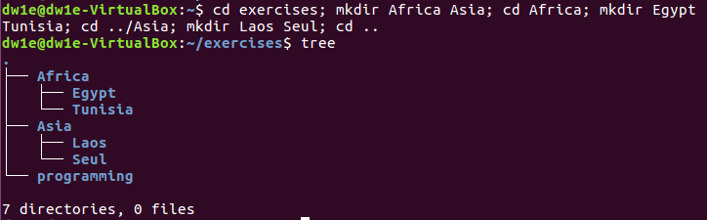

We can also create that structure typing **<mkdir -p Africa/{Egypt,Tunisia}** to create the three of them with just one command.

**The comma (,) is needed when using “{}” to create sibling directories. If we don’t use it we need to type the path with spaces between the directories, for example **<mkdir -p Africa/Egypt Africa/Tunisia>**

1. For this exercise we need to first access the directory specified (**<cd directory_name>**) and create the file using *nano* so that we can edit it at the same time (we type **<nano file_name.file_extension**).

**<cd Africa/Egypt>**

**<nano song.doc>**

**Now write some lyrics and press CTRL + X , Y and Enter to exit after saving the lyrics and the file name.

**It is right, but Sergio did everything from “exercises”, using the path for the creation of the new file (for example **<nano Africa/Egypt/song.doc>**)



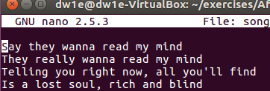

Now we change the directory to Seul (**<cd ../../Asia/Seul>**) and now we do the same with a new file (“tv.doc”), where we will write our favourite TV Show.

**<cd ../../Asia/Seul>**

**<nano tv.doc>**

**Now write our favourite TV Show and press CTRL + X , Y and Enter to exit after saving the name of the show and the file name.

**It is right, but Sergio did everything from “exercises”, using the path for the creation of the new file (for example **<nano Asia/Seul/tv.doc>**)



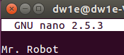

Finally, we need to do the same for a new file located in “Tunisia”, called “marks” (without extension).

**<cd ../../Africa/Tunisia>**

**<nano marks>**

**Now write our marks and press CTRL + X , Y and Enter to exit after saving the marks and the file name.

**It is right, but Sergio did everything from “exercises”, using the path for the creation of the new file (for example **<nano Africa/Tunisia/marks>**)



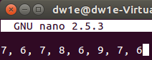

1. Now we need to copy our “song.doc” from Egypt

**FROM NOW ON WE SHOULD ONLY MOVE INTO “AFRICA” AND REMAIN THERE TO DO THE REST OF THE EXERCISES**

**<cd Africa>**

**<cp Egypt/song.doc ../Asia/Laos>**

**<cp -R /home/dw1e/exercises/Africa/Egypt/song.doc /home/dw1e/exercises/Asia/Laos>**



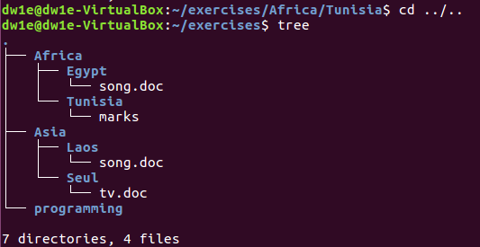

**<mv /home/dw1e/exercises/Asia/Seul/tv.doc /home/dw1e/exercises/Africa/Egypt/radio.txt>**

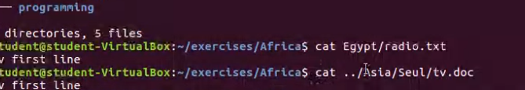

**<cat Egypt/radio.txt>**

**<cat ../Asia/Seul/tv.doc>**

**<mv /home/dw1e/exercises/Africa/Tunisia/marks /home/dw1e/exercises/Africa/Tunisia/exam.wri>**

**<mv Tunisia/marks Tunisia/exam.wri>**

**<cp Egypt/song.doc Tunisia>**

**<cp /home/dw1e/exercises/Africa/Egypt/song.doc /home/dw1e/exercises/Africa/Tunisia>**

**suponemos que es Tunisia el directorio al que se refiere

cd Africa7Tunisia

ls -l

**<mv ../Asia/Laos/song.doc>**

mv /home/dw1e/exercises/Asia/Laos/song.doc /home/dw1e/exercises/Asia/Laos/aa.doc

**<mkdir ../Asia/Laos/Others>**

cd Asia/Laos

mkdir Others

**<mv ../programming --/pro-c**

cd programming

mv programming pro-c

1. wrong ?

mkdir -p one/two/three

**<mkdir -p ../ONE/TWO ../ONE/THREE>**

cp (-R ?) /home/dw1e/systems/*txt /home/dw1e/exercises

**<cp ../../systems/*txt ..>**

mv /home/dw1e/exercises/*txt /home/dw1e/exercises/one/three

**<mv ../*txt ../ONE/THREE>**

rm -rf ../one/three

cp -R /home/dw1e/systems/*txt /home/dw1e/exercises/Africa/Tunisia

**<cp $HOME/systems/*txt $HOME/exercises/Africa/Tunisia>**

cp -R /home/dw1e/exercises/Asia/Seul/tv.doc /home/dw1e/exercises

**<cp $HOME/exercises/Asia/Seul/tv.doc $HOME/exercises>**

mv /home/dw1e/exercises/Africa/Tunisia/student1.txt /home/dw1e/exercises/Tunisia/tuition.txt

**<mv $HOME/exercises/Africa/Tunisia/student1.txt $HOME/exercises/Africa/Tunisia/tuition.txt>**

→ (posiblemente más fácil: cd Africa/Tunisia; mv student1.txt tuition.txt)

**<mkdir -p $HOME/systems/earth/countries>**

cd $HOME

mkdir -p /systems/earth/countries

**<mv $HOME/exercises/Africa $HOME/exercises/Afri>**

cd ../exercises

mv Africa Afri

**<cd $HOME/exercises>**

**<mv Afri/Egypt/song.doc Asia/Laos/bb.doc>**

mv /home/dw1e/exercises/Afri/Egypt/song.doc /home/dw1e/Asia/Laos/bb.doc

cd ..

cp /home/dw1e/systems/*u* /home/dw1e/exercises

**<ls -rR /etc>**

ls -r /etc

pwd

**<cd $HOME/exercises>**

**<cp -R Afri Asia>**

cp -R /home/dw1e/exercises/Afri /home/dw1e/exercises/Asia

(located in Asia) **<mv Laos Seul/Seul2>**

mv /home/dw1e/exercises/Asia/Laos /home/dw1e/exercises/Asia/Seul/Seul2

**ALFREDO PUERTA GALLEGO DW1E**